* This program was a simple calculator using basic arithmetic operators like addition (+), subtraction (-), multiplication (\*), and division (/).
* In this arithmetic calculator, created four methods with arithmetic operator names like addition, subtraction, multiplication, and division.
* Then, we will first take two numbers in input from the user, by using the scanner class in a program.
* The value is stored in a variable using a double format.
* Because the double data type contains a high limit, so double is useful to get an accurate result.
* Then after giving two inputs the Arithmetic operations is the display with a choice to select in number format.
* This display operation is processed by a switch case. The first case display addition, the second case display subtraction, the third case display multiplication, the fourth case display division, and the default case is displayed if the choice is not correct it shows an invalid choice.
* The user selects the first case it goes to the first switch case.
* That switch case contains obj.addition(input 1, input 2) it goes to a method addition created before in the program.
* In that method, the input value given by the user is to get and process the addition operation inside the method and print the result.
* Then it goes to the switch case and the function of the first case will break.
* 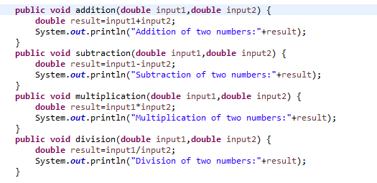The methods used in the program are given below